Looking up Base Pay in Workday
Authorized Uses Only: Use of this information is limited to proposal preparation and governed by the University Acceptable Use Policy. Any other use is unacceptable.

- Enter person’s name in Search bar and hit enter.
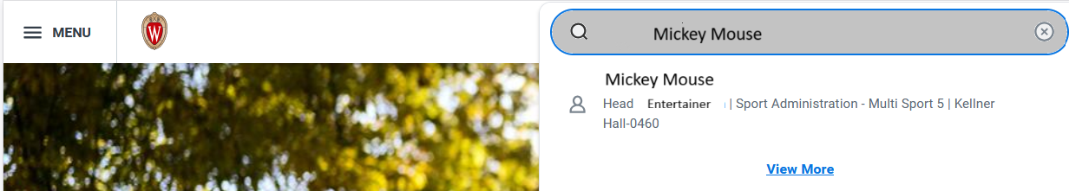
- Click on name.
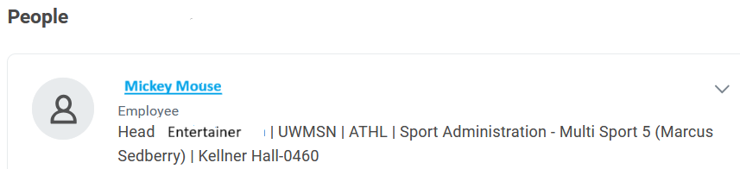
- From left side menu, pick Compensation.
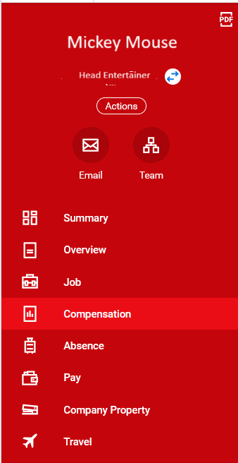
- Base salary info is listed on Compensation tab.

Updated 9/13/2025

